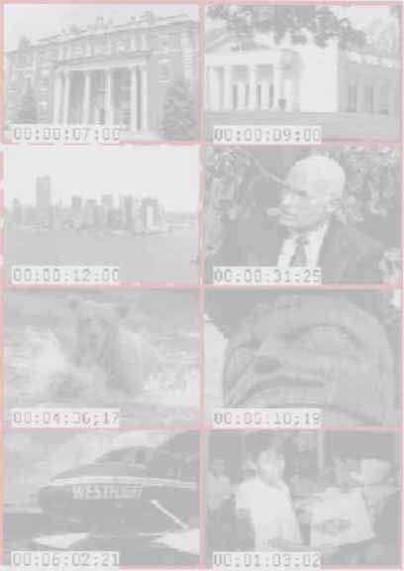
Scene Stealer

User’s Guide
Version 2

 | DUBNER INTERNATIONAL,Inc.  13 Westervelt Place  Westwood, New Jersey USA 07675-1921  Tel: 201-664-6434  Fax: 201-358-9377  rdubner@compuserve.com

NOTICE: DUBNER INTERNATIONAL, Inc. makes no warranty of any kind with regard to this material., including, but not limited to, the implied warranties of merchantability and fitness for a particular purpose. DUBNER INTERNATIONAL, Inc. shall not be liable for errors contained herein or for incidental consequential damages in connection with the furnishing, performance, or use of this material.

This document contains proprietary information which is protected by copyright. All rights are reserved. The information contained in this document is subject to change without notice.

DUBNER INTERNATIONAL, Inc. has applied for patents protecting the technology used in Scene Stealer.

January 1, 1998

©Copyright 1993-1998 DUBNER INTERNATIONAL, Inc.

C O N T E N T S

Glossary of Terms 1
1. Installation 3
Hardware 3
Installing the Circuit Board 3
Connecting the Video Source to the Board 4
Software Installation 4
Creating the Scene Stealer Icon in Windows 3.1 5
Setting Properties in Windows 95 6
Reading Timecode 8
Standard Sony Serial Protocol 8
Sony Protocol Emulators 8
BUF Technologies Tapedeck Controllers 8
VISCA Hi-8 RC Control Protocols 8
PC Expansion Boards that Read LTC Directly 8
Audio Support 9
Configuring the Sound Blaster for Windows 3.1 9
Setting Sound Blaster Mixers 10
Configuring Audio Boards Under Windows 95/NT 10
2. Setting up the GRAB 11
3. Grabbing Video 13
Files Created by the GRAB Program 14
Changing the Size of Color Images 14
4. File Menu Items 15
Scene Stealer Files 18
5. Edit Menu Items 21
6. Options Menu Items 23
7. A Sample Logging Session 27
Grab Video 27
Log Video 28
Log Audio 30
Additional Logging Features 31
8. Microsoft Access Support 33
Preparing Data for Export to Access 33

Glossary of Terms
Active Video Frame: As you advance the video frames in a Scene Stealer reel, one picture changes immediately, and after a short pause, the other pictures update. We call the changing picture, the “active” frame. To identify this frame with a dashed-white border, open a Scene Stealer video file and select OPTIONS/Active Frame ID.

Annotations: Comments or other typed entries entered by the user in the Scene Stealer text box. Annotations apply to an entire scene.

Burst: The first grabbed image of each scene.

Continuous: The mode of grabbing video at user defined intervals. We recommend Continuous mode. Cut points are automatically detected to frame accuracy regardless of the frequency of the Continuous GRAB.

Cut point: The location where one scene ends and the next begins.

Endpoint: The timecode at the end of a scene.

Grab: The process of digitizing video tape and storing it on the hard disk of your computer.

Hard copy: Printed images that were flagged with an “H”. The images are organized by time code in rows and columns and may be accompanied with or without text entries. WARNING: Scene Stealer prints only images that have comments. If you have not typed a comment, choose EDIT/Annotate Every Cut which numbers every scene. The number serves as a comment. When you format your printed page, you may include the comment or not.

Head frames: The first Scene Stealer stored video frame of each scene.

Inpoint: The timecode of the beginning of the scene.

Master reel: The video originally grabbed by Scene Stealer.

Museum: The process of paring down or archiving parts of a master reel into a new, smaller master reel. “M” flagged images are transferred into a new file.

Outpoint: See Endpoint.

Storyboard reel: A reel in which scenes from master reels are assembled, trimmed and reviewed. Storyboard reels are identified by the letters [S/B]. A Storyboard Reel consists of pointers into the original Master Reels. Storyboard Reels work properly only if the original Master Reels still exist on the computer.

Tail frame: The last Scene Stealer stored video frame of each scene.

Window dub( window burn): Time code burned into the video image.

1. Installation
Scene Stealer requires that the Windows video display driver be configured for at least 256 colors.

Hardware
Before installing the Scene Stealer board, consider how you intend to connect video to the Scene Stealer and any other devices you may be using.

An ordinary video signal must be terminated to 75 ohms. An unterminated signal will be too bright. A signal that is terminated more than once will be dark and muddy. In either case, the Scene Stealer may have difficulty locking to the video signal.

Ordinary TV sets have a built-in 75-ohm terminator, as do the common color capture boards. Some monitors have dual BNC “loop-through” connectors with a 75-ohm termination switch; still other professional monitors, notably Sony’s, have no switch but are “smart” – they detect the need for termination and automatically configure themselves.

The Scene Stealer board only has one BNC connector. The on-board 75-ohm terminator can be disabled by removing the jumper next to the BNC connector. A common BNC “T” adapter must then be used to loop the signal through the Scene Stealer board.

If you use the optional color capture board, remember that it has a built-in 75-ohm terminaton. A typical arrangement would be to remove the Scene Stealer’s terminator jumper and to use a “T” on the Scene Stealer’s BNC connectory. The video comes from the tape deck, goes to the Scene Stealer, and from there to the color capture board. If you also run that signal to a monitor, the monitor must be of the type whose 75-ohm termination can be disabled.

Once you have decided whether to leave the Scene Stealer’s 75-ohm termination jumper in place, you can proceed to install the circuit board into your computer.

Installing the Circuit Board
To install the board into the computer, follow the manufacturer's instructions for removing the case cover. Insert the Scene Stealer board into any empty ISA slot.
If you intend to use the optional color capture board, install it in any PCI slot.
Replace the computer's case cover, and turn the computer on.

Connecting the Video Source to the Board
The board has a BNC connector, which is the standard connector for baseband video on professional video equipment.

If you are using home VHS equipment, most likely you'll have to purchase adapters.

Video cable purchased at Radio Shack, for example, has F-type connectors. (That's the type with a short piece of solid copper wire visible in the center of a screw-threaded assembly about 0.35 inches in diameter.) That cable won't match either the VCR or Scene Stealer, so you need two adapters.

- The Radio Shack 278-252 Video Adapter matches the F-type cable connector to the baseband video output of the VCR, usually an RCA phono jack color-coded in yellow.

- The Radio Shack 278-251A RF Adapter matches the other end of the cable to Scene Stealer's BNC connector.

Software Installation
Insert the Scene Stealer diskette into the floppy drive. From the floppy double click on install.exe. The program asks what directory path to use for installing Scene Stealer files, offering as a default

C: \GRAB

You can change the default to something else or proceed, following the instructions on the screen.

NOTE: Because the Scene Stealer program is a 16-bit application, it has difficulty processing the 255-character long file names allowed under Windows95 and WindowsNT. Don’t use long file names, and don’t use names that contain spaces.

To install the software for the optional color frame grabber, insert the diskette or CD-ROM that is supplied with the board and run the SETUP program.

Creating the Scene Stealer Icon in Windows 3.1
In the Windows Program Manager,
Click on File, then New

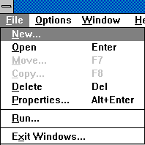

Click on Program Group, then OK.

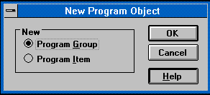

Type the following information :
Description: Scene Stealer
Group File: Stealer

Click OK.

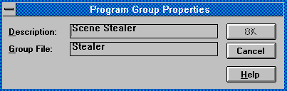

The result is an empty program group box.

Reselect File and New.
Click on Program Item then OK.

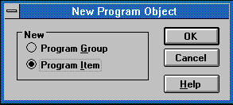

Type the following information:
Description: Scene Stealer
Command Line: c:\grab\stealer.exe
Working Directory: c:\grab

Click OK. The Scene Stealer icon (a traditional clapper slate) appears.

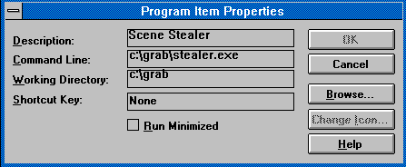

Setting Properties in Windows 95
Add Scene Stealer to the START menu, or as a shortcut on the desktop. The default location of the executable is C:\GRAB\STEALER.EXE.

The following is one procedure which puts the Scene Stealer icon and the folder for the data files onto the desktop:

1) Use Windows Explorer to create a folder called C:\SSDATA:

Click Start
Select Programs
Select Windows Explorer
In the left panel, left-click the C: drive
In the right panel, right-click on an empty space
Select New
Select Folder
Enter the name SSDATA

2) Create a shortcut on the desktop to that new folder:

Right-click on an empty part of the desktop
Select New
Select Shortcut
Enter C:\SSDATA as the Command Line
Click Next
Enter SSDATA as the name
Click Finish

3) Create a shortcut on the desktop to Scene Stealer:

Right-click on an empty part of the desktop
Select New
Select Shortcut
Enter C:\GRAB\STEALER\GRAB.EXE as the command
Click Next
Enter Scene Stealer as the name
Click Finish
Right-click the new icon
Select Properties
Select Shortcut
Change Start In to C:\SSDATA
Click OK

To make sure the properties of the GRAB and POST programs are correct:

Start Windows Explorer
In the left panel, click drive C:
In the right panel double-click the C:\GRAB folder
In the right panel, right-click GRAB.EXE.
Select Properties
Select Program
Check Close On Exit
Click OK

In the right panel, right-click POST.EXE.
Select Properties
Select Program
Check Close On Exit
Click OK

That completes the installation process.

Reading Timecode
Scene Stealer brings in timecode in a variety of ways The actual selection of a particular technique is controlled by the Grab/Parameters dialog box. Here is a list of the options available.

Standard Sony Serial Protocol
Professional videotape players often are configured with timecode readers that follow the standard Sony serial protocol.

Computers usually have serial ports that use RS-232 voltage levels. Scene Stealer can be configured to communicate with a serially-controlled deck with an RS-232 to RS-422 converter.

Sony Protocol Emulators
There are products which take either VITC or LTC timecode directly from a deck and emulate the Sony serial protocols. Products made by Telcom Research and Adrienne Electronics Corporation communicate directly in RS-232, so no converters are necessary.

BUF Technologies Tapedeck Controllers
BUF Technologies, Inc. makes a tapedeck control unit that can be interrogated for timecode values. Scene Stealer can talk to the BUF Technology controllers.

VISCA Hi-8 RC Control Protocols
The Sony Corporation manufactures Hi-8 videocassette decks that incorporate RC (Rewritable Consumer) timecode. Accessing RC timecode involves being able to talk to the deck using the VISCA (Video System Control Architecture) protocols. Scene Stealer can be configured to use the VISCA protocols.

PC Expansion Boards that Read LTC Directly
There are a number of different circuit boards that plug directly into the PC, and which read timecode. Scene Stealer can be configured to talk to several of these boards.

Adrienne Electronics sells the PC-LTC/IOR reader board. This board reads LTC; Adrienne also builds a similar board that reads VITC.

Prevue Technologies builds the TR-100 LTC reader board. The TR-100 board is a popular one. It has been around for years, and has been sold under other names (Robertson Engineering and Cardinal Video, among others). It has also been supplied by D/Vision and other editing systems.

Audio Support

Scene Stealer’s audio capture capability is markedly different under Windows 3.1 versus Windows 95 or Windows NT.

Under Windows 3,1, Scene Stealer shuts Windows down completely and uses a DOS program (called GRAB.EXE) for doing the grab. The DOS program only works with sound capture boards that are 100% compatible with Creative Labs Sound Blaster boards.

Under Windows 95 or Windows NT, WINGRAB.EXE does the grab. This program uses system drivers for capturing audio, so in principle any sound capture board can be used.

In either case, Scene Stealer configures the board to grab a single channel of 8-bit audio. This configuration minimizes the amount of storage needed for the digitized audio, but still gives adequate performance for logging and transcription.

Likewise, in either case you will typically connect your deck’s audio output to the audio capture board’s LINE input.

Configuring the Sound Blaster for Windows 3.1
Scene Stealer requires a sound board that is 100% compatible with the original Creative Lab's Sound Blaster board. Some boards require the use of a configuration program (supplied by the manufacturer) to put the board into a Sound Blaster compatible mode.

Scene Stealer handles any valid configuration of Base I/O address, Interrupt Request IRQ line, and DMA channel. Scene Stealer determines those values by looking for a BLASTER= environment variable; that variable is established by a SET BLASTER= statement in your AUTOEXEC.BAT file.

If there is no SET BLASTER= statement, the default values of address 0x220, IRQ5, and DMA channel 1 are used. Nonetheless, we highly recommend the use of a SET BLASTER= statement. When you let the Creative Labs installation process proceed automatically, the correct SET BLASTER= statement is included in your AUTOEXEC.BAT file.

Once that is done, you are ready to attach an audio cable from your tapedeck to the Sound Blaster board.

Setting Sound Blaster Mixers
The Sound Blaster 16 board, which is in wide use, has separate audio mixers for the inputs to the digital recorder, and to the audio output drivers.

The Creative Labs installation process for the Sound Blaster 16 installs an SB16 Program Group. One of the programs is the Creative Mixer. When you run it, you are confronted with an audio mixer control panel. You are mainly interested in the LINE control — the pictorial representation is a small phone plug.

Set the LINE input level somewhere near the maximum level, and make sure the red dot check box has a red dot in it — that connects the LINE input to the digital recording mixer. (The green dot connects it to the audio output, which allows you to monitor the audio as it is being recorded.)

Configuring Audio Boards Under Windows 95/NT
Since each board comes with its own driver, it is difficult to generalize instructions. Select the Multimedia icon in the Windows Control Panel. If you can select the “Show volume control on taskbar” checkbox, then do so. A volume control appears on the taskbar next to the clock; double-click on it to bring up the volume controls.

There might be separate controls for the output audio levels and the recording input levels. Select the recording levels and make sure that the LINE input is enabled and that the level control is towards the top.

2. Setting up the GRAB

The first stage of Scene Stealer logging is grabbing video.

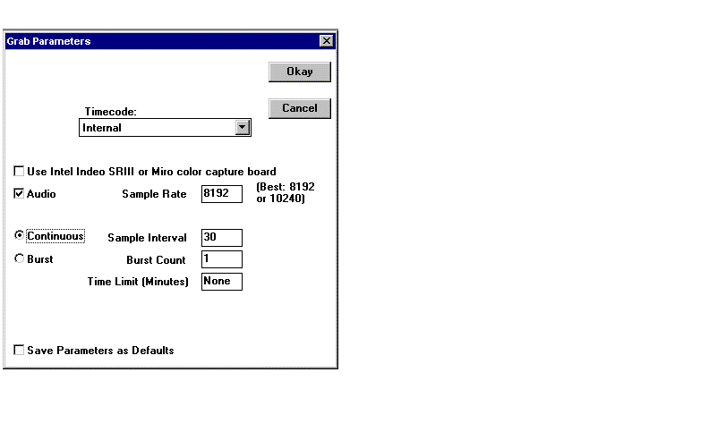Select Grab/Parameters.

Timecode: The heading for timecode options.

Internal: Counts the grabbed frames and generates numerical reference points that can be recalibrated to match a window burn.
Select internal if you are not reading timecode from your tape deck.

Standard Sony COM1-4: Reads timecode with an RS232/422 data converter.

PreVue TR-100 LTC Board: Communicates with PreVue Technology LTC Reader Board.

AEC PC-LTC/IOR Board: Communicates with Adrienne Electronics LTC Reader Board.

BUF VTC-2000:Com 1-4: Communicates with BUF Technology Controller.

Sony VISCA: Communicates with Hi-8 video cassette tape decks that incorporate RC timecode using Sony Visca protocols.

Panasonic 7350 Com 1-4: Communicates with Panasonic tape decks and an RS232/422 data converter.
Sony UVW 1200/1400 COM 1-4: Reads timecode directly from RS232 tape deck.

Use … color capture board: Grabs color video. Requires a color frame
grabber. As of this writing the Intel Smart Video Recorder III board works well, as does a Stealer-in-Color capture board that we supply.

Audio: Grabs continuous audio. Requires an installed sound board.

Sample Rate: Sets the audio sample rate. We recommend a sample rate of
8192 or 10240 samples per second.

Continuous: Grabs pictures at timed intervals.

Sample Interval: Sets the number of frames between grabs.
A value of 30 digitizes one picture every 30 frames which is one frame per second of NTSC video (one picture every 25 frames is one frame per second of PAL video). A value of 15 grabs two frames of NTSC video per second. 60 grabs one frame every two seconds.

Burst: Grabs pictures at each scene change based on the sample interval and burst count.
We recommend using the Continuous mode. Too much data is probably better than too little. In the burst mode, if there are no scene changes, Scene Stealer captures no images, and you might miss something.

Burst Count: Specifies number of frames to grab per scene.
Example: If Burst is selected and 5 is the Burst count and 30 is the Sample Interval, Scene Stealer grabs five frames at one second intervals and then waits until another cut is detected before continuing to grab. A burst count set at one, digitizes one frame every scene.

Time Limit: Specifies the length in minutes of an unattended grab.
If this value is set to zero, Grab runs forever, or until you have less than about 100,000 bytes of free disk space.

Save Parameters as Defaults: Stores the settings for video grab until they are manually changed.

3. Grabbing Video

Grab/Grab As

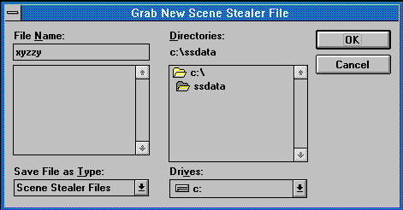

Select a directory and type a file name and then start your deck

OK starts the GRAB.
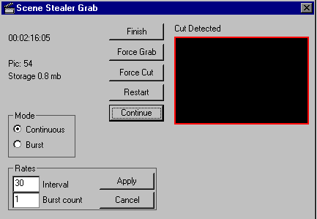

The window in the upper left corner displays running timecode.

Pic: Displays the number of grabbed or stored video images.

Storage: Displays the amount of bytes being used.

The following pushbuttons set parameters any time during the GRAB. (Once a button is clicked with the mouse, it becomes the active button. It can subsequently be “pushed” again either with the mouse, or by pressing the keyboard “Enter” key.

Force Grab: Overides the set parameters forcing Scene Stealer to GRAB and store a picture.

Force Cut: Overides the set parameters forcing Scene Stealer to insert a scene change point.
Restart: Clears out all the current Scene Stealer files resetting the counters to zero. GRAB automatically restarts at this point.

Pause/Continue: Halts picture processing.
Timecode continues to run but no pictures are stored until you click Continue. This function is useful for skipping tape that you know is uninteresting.

Finish: Ends the GRAB. When GRAB terminates, the grabbed video thumbnails appear on the screen. This is the master reel.

Files Created by the GRAB Program
.SD1 contains all the grabbed video pictures (can become very large).

.SD2 contains a series of indices into the .SD1 file. Both .SD1 and .SD2 are necessary; one is useless without the other.

.SD3 contains the raw scene change data accumulated during the GRAB (can become moderately large).

.SD5 contains the grabbed audio (can become very large).

.SD6 contains the indices into the .SD5 file

Changing the Size of Color Images
Color capture cards typically have the ability to grab images in varying resolutions. The image size is controlled by software supplied with the board by the manufacturer. VIDCAP or VIDCAP32 is usually the program that is used to change the size of the image along with other video parameters such as brightness and contrast. Use that supplied program to change the image parameters before starting a Scene Stealer grab.

The larger the image, the more storage is required. Each 160 by 120 color image requires 57,600 bytes of storage; each 320 by 240 color image requires 230,400 bytes of storage. Make sure you have adequate disk storage space before embarking on large-scale grabs of large images.

4. File Menu Items
This chapter describes the File menu.
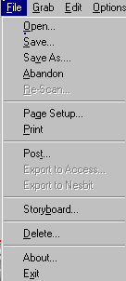

Open: Opens previously saved master or storyboard reels.

Save: Saves the current active reel.

Save as...: Saves the active storyboard reel with a new name.
“Save as” cannot be used with a master reel.

Abandon: Closes the current reel without saving files.

Rescan: Processes raw scene change data with new parameters.
Annotations already made are lost.

Lowering the 1300 default threshold makes the cut detector more sensitive; lowering it much below 700 gets into the noise level. Setting the threshhold to 64,000 wipes out automatically marked scene detection points leaving only manually inserted cut points.

The whip detection algorithm is sometimes useful for locating “whip pans”. It may flag other unwanted motion as cuts. Experiment with both the number of frames and the threshold level.

Page Setup: Displays the options for formatting printed pages of selected images.

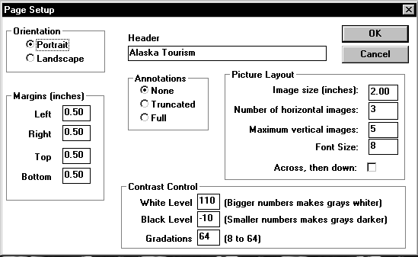
Orientation and Margins use typical Windows conventions.

Header: The title for your printed page.

Annotations: Sets attributes for displaying text on the printed page.
None: Prints images and timecode data in any layout of columns and rows. No text is printed.
Truncated: Cuts text, if necessary, to make room for the maximum number of pictures in a one column display.
Full: Prints all text for each picture in a one column display.

Picture Layout: Image size (inches): Sets the dimension of squared printed pictures.

Number of horizontal images: Sets the number of pictures per row.
This number dominates. If the number of horizontal images is too great for the image size, the pictures will be shrunk to fit on the page.

Maximum vertical images: Sets the maximum number of pictures per column.

Font size: Sets the font size for text and timecode.

Across, then down: Organizes the images by timecode either across (horizontally) the page or down (vertically).

Contrast control:Changes white and black levels.
Try the default settings before changing them. Because printers respond differently, you may need to experiment to find your ideal settings.

Note: After you click OK, File/Print sends the data to the printer.
Print: Prints using typical Windows95 conventions.
To print pictures on another computer, set the destination to be a file. For example, you can specify a:print.dat. After the file is created, take that diskette to the other computer and execute the DOS command:

copy a:print.dat lpt1: /b

Post: Activates export and archive functions.
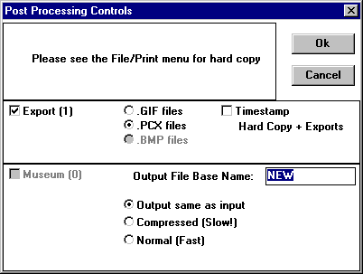

Export (N): Indicates the number of pictures flagged for export as .GIF, .PCX, or .BMP files.
Color images export as .BMP files. Monochrome images can be .GIF or .PCX. Exported pictures are named PICxxxx.GIF, PICxxxx.PCX, or PICxxxx.BMP.

“E” for Export flagged pictures are also listed in the special .TEL file designed for transferring pictures or annotations into custom database programs. “E” flagged pictures transfer to Microsoft Access using the FILE/Export to Access command.

Timestamp: Superimposes timecode on the exported images.
(Timecode is only stamped on monochrome exported .GIF or .PCX images, not the color .BMP images.)

Museum (N): Indicates number of pictures flagged for archiving into a separate file.

Output File Base Name: The typed entry becomes the new file name.

Output same as input: Keeps the same compression method for the output as the input picture. This is the recommended choice.
Compressed (Slow): An average monochrome picture uses 9,000 to 11,000 bytes of storage rather than the uncompressed 16,564 bytes. Compression drastically slows display and the decompression time is significant. We don’t recommend it, and we shortly anticipate removing it completely.

Normal (Fast): Stores pictures in uncompressed mode.

Export to Access: Transfers “E” marked pictures into a Microsoft Access database.
See Chapter 8, Microsoft Access Support.

Export to Nesbit: Transfers “E” marked pictures into a Nesbit Media Library Program.
Contact Nesbit for further information.

Storyboard: Opens an empty storyboard reel to assemble scenes selected from other reels.

Delete: Deletes video and various data files.

About: Displays program and Dubner International contact data.

Exit: Closes the Scene Stealer program, closes all open reels, saves new data and creates a number of files.

WARNING: If you open the same reel several times making changes to some of them, they will all get saved—one on top of the other! There is no way to know what the order will be.

Scene Stealer Files
.SD4: Contains all the annotations, flags, cut points, etc., that the Scene Stealer program needs.

.SD!: Contains a backup of the previous .SD4 file. If necessary:
- save the new .SD4 file with a new name
- rename the .SD! file as .SD4
- and then reopen the reel.

.NOT: Contains your comments in a CMX-340 edit list. If you rename it .EDL, it can be imported by EMC² and other editors.

.TAB: Contains timecode and comments in a tab-delimited text file.

.DBT: Contains timecode and comments in a quote-delimited, comma-separated text file.

.TEL: Contains data for transferring picture, timecode and text to relational database programs.

.VCB: Contains timecode and comments in a file used as a batch-digitize file in Scitex editors.

.ALE: Contains timecode and comments in a file used as a batch-digitize file in Avid editors. Specifically, this file matches the Media Composer format.

.PWR: Contains timecode and comments in a file used as a batch-digitize file in a Media 100.

If the very first character of a scene's annotation is a colon (":"), then the following word is placed in the CLIP_NAME field of the .VCB, .ALE, and .PWR entries for the scene. If there is another colon in the first line of the entry, then the entire phrase between the colons becomes the CLIP_NAME.

.TXT: Contains comments in an easy-to-read text format. The D/Vision editing system uses this file as a batch digitizing file.

.TX2: Contains comments in a format easily transferred into other word processing programs.

.EDL: When you close a storyboard reel, the Scene Stealer program creates an .SD4 file and an .EDL file. The .EDL file is a CMX-340 edit list file that contains the edit commands for assembling a videotape that corresponds to the rough assembly in the storyboard. .ALE and .TAB files with the same information are also created.

Closing a storyboard reel also creates a series of .TXT files, one for each master reel involved in the storyboard. These .TXT files can be used with D/Vision editing systems to batch digitize all of the clips needed to produce the product; the .EDL is used to assemble the digitized clips in the proper order.

5. Edit Menu Items

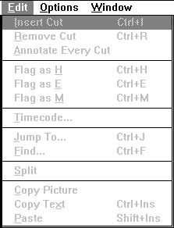

Insert Cut: Enters a new cut point (inpoint) at the active picture and rims it in red.

Remove Cut: Removes the cut point, eliminating the red rim.

Annotate Every Cut: Numbers every scene.
Scenes with comments are not affected; scenes that have no comment are marked with a sequence number.

Flag as H

Flag as E

Flag as M
Toggles the Hard-Copy, Export, or Museum flags of the active frame.

To display a floating menu for HEM flags, position the mouse over any image and depress the right mouse button. The floating menu displays selections for marking individual frames, all head (first) frames, all head and tail (first and last) frames, or an entire scene. H flagged images require a comment or sequence number. See “Annotate Every Cut” above.

Timecode: Allows the Scene Stealer's internally-maintained timecode to be changed.

Of Current Picture: Coordinates the Scene Stealer's timecode with the timecode visible in a “Window Dub”. When you enter a timecode, the program calculates an offset which is used for that scene forward to either
- the end of the reel, or
- another explicitly established timecode offset.

Of Current Scene: Defines a particular cut point near the beginning of the reel as being, for instance, 01:00:00:00. You can then tell the person editing your tape which cut should be defined 01:00:00:00 and thus coordinate your comments and cut points with the actual videotape. Of Current Scene is useful when you don't have a window dub or external timecode available.

Jump To: Jumps to a specified point in the reel based on timecode.

Find: Activates a simple text matching function to search the current active reel, or all open reels.

Split: Divides a reel into two reels. The split takes place at the current active picture.

Copy Picture: Copies the current picture into the Windows Clipboard.

Copy Text: Copies text from the text box to the Windows Clipboard.

Copies highlighted text to the Clipboard. If no text is highlighted, copies reel name, in/outpoint, scene duration, and text.

Paste: Copies text from the Clipboard into the text box at the current cursor position.

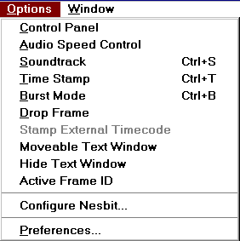
6. Options Menu Items

Control Panel: Toggles the display of Scene Stealer's video playback control panel.

Control Panel | Description | Keyboard Command
< and > | Moves the display backward and forward one picture. | →←
|< and >| | Jumps the display to the previous and following cut points. | - +
|<< and >>| | Shuttles the display to the previous and following cut points. | Page Up  Page Down
<< and >> | Shuttles the display backwards and forwards. | 5→ 5←  (hold 5 and right arrow or 5 and left arrow on numeric keypad)
Audio | Starts continuous audio track. | Insert  (on numeric keypad)
Stop | Stops any ongoing shuttle. | 5  (on numeric keypad)
+ and – | Adjusts the shuttle speed.
 | Jumps to the beginning/end of the reel. | Home  End

Audio Speed Control: Displays a sliding bar to speed up or slow down audio playback.

Soundtrack: “Displays” the soundtrack in reels that contain stored audio.

Time Stamp: Displays a timecode window on each image. HEM flags appear in the Timestamp window for flagged pictures.

Burst Mode : Displays only the head frames for each scene.

Drop Frame: Sets the current reel to Drop Frame timecode.

Stamp External Timecode: Displays timecode read from the tapedeck.

Moveable Text Window: Allows the mouse to change the size and position of the text box.

Hide Text Window: Removes the text box.

Active Frame ID: Identifies the active picture with a dashed white border.

Preferences: Calls up a dialog box to set configurations.

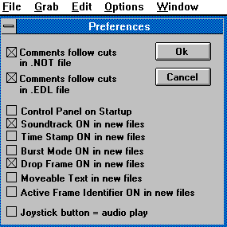

The following two checkboxes format the two CMX-340 edit list files created by the Scene Stealer.

Comments follow cuts in . NOT file.
Comments follow cuts in .EDL file.

Otherwise, the comments preceed the cuts in the .NOT and .EDL files – there is no accepted standard, and various editors expect the comments either before or after the cut information.

The following seven checkboxes toggle the status of each option.

Control Panel on Startup.
Soundtrack ON in new files.
Time Stamp ON in new files.
Burst Mode ON in new files.
Drop Frame ON in new files.
Moveable Frame Identifier ON in new files.
Active Frame Identifier ON in new files.

Joystick button = audio play: Enables the use of a joystick or foot switch for controlling audio playback.
Connecting pin 2 to pin 4 on the 15-pin joystick or gameport connector starts audio playback. Opening that connection stops audio play.

A footswitch to make that connection is useful for transcribing. A footswitch and cable assembly are available from Dubner International.

The following menu items use typical Windows conventions.

Window

Tile

Cascade

Arrange Icons

Close All

7. A Sample Logging Session

Grab Video
Insert tape into the tape deck.

Click on Scene Stealer’s icon.  | Opens the Scene Stealer Program.
GRAB/
PARAMETERS
Timecode | Choose timecode input. Use Internal if you have no external timecode input. Internal is particularly useful for working with window burns.
Audio | Select if appropriate.
Sample Rate | Leave default 8192.
Continuous | Select.
Sample Interval | Leave default 30 (25 for PAL).
Time Limit | Type 2 (for grabbing two minutes of video).
OK | Click OK. Start the tape deck.
Grab/
Grab as
 | Type a name for your test file.
OK | Click OK. Scene Stealer grabs one frame per second of video. The first grabbed video frame of each scene is rimmed in red.  After two minutes Scene Stealer automatically stops and displays the first series of frames.  The set of three numbers at the lower left corner indicate the timecode of the inpoint, the current frame, and the endpoint of the first scene.

Log Video
OPTIONS/  CONTROL PANEL | Toggles the control panel display. Keep it on.
OPTIONS/  SOUNDTRACK | Toggles the soundtrack display. Keep it on (if you have grabbed audio).
OPTIONS/  TIME STAMP | Toggles the timecode window. Keep it on.
OPTIONS/  ACTIVE FRAME ID | Toggles the dotted rim which identifies the active video frame. Keep it on.
OPTIONS/  BURST MODE | Toggles the video to display the first frames only of each scene. Keep it off so that the display is continuous.
Click >> on the control panel | Shuttles through the grabbed video until the end of the tape. This is a fast way to review your whole tape.
Home | Jumps to the beginning of the grabbed video.
Type a comment. | The comment for the current scene appears in the text box.
Click >| and type another comment. | Displays the comment for the next scene.
Click >| | Jumps to the next scene.
EDIT/  REMOVE CUT | Offers rough-cut editing to remove the cut point from the current location.
Click > and select  EDIT/  INSERT CUT | Changes the cut point to a new location.
EDIT/  TIMECODE | If you work with a timecode window burn visible on your tape, use this command to recalibrate Scene Stealer’s internal timecode to match the display. Type your numbers and click OK.
RIGHT MOUSE BUTTON | Selects images for print, export and archive.
To Print: Hold down the right mouse button, slide the mouse to Hard Copy, then to Heads Only. | Flags the first frames of each scene for printing.  WARNING: Scene Stealer prints only images that have comments. If you have not typed a comment for each scene that you want printed, choose EDIT / Annotate Every Cut. This command numbers every scene. The number serves as a comment.
FILE/PAGE SETUP | Fill in the blanks to format the printed page.
FILE/PRINT | Sends the data to your printer.
To Archive or create a smaller file from your master reel. Holding the right mouse button down, slide the mouse to Museum, then to Entire Scene. | Flags scenes for saving in a separate file. An “M” appears on every frame within each selected scene.
FILE/POST | Type a name for the new file in the window Ouput File Base Name. Click OK to create a file with the flagged scenes.
FILE/STORYBOARD | Opens a blank reel for assembling scenes.
Select the master reel and  > |. (Repeat if necessary.) | Jump to any scene in the master reel to place it at the start of the storyboard.
Double click and hold down the left mouse button. Drag the scene to the storyboard. | Copies and pastes the scene from the master reel to the storyboard. When you copy scenes from a master reel into a storyboard, audio and text come along. You can’t change the audio, but you can edit the text.
In the storyboard, place the mouse over the last frame. Click the right mouse button to display a floating menu. Select Insert Cut Point. | Inserts a red rimmed border on the last frame, indicating the beginning of a new scene.  When you insert a cut point, you can move to the scene before or after the cut point, and use Delete Scene to get rid of it.
Use the right mouse button to redisplay the floating menu. Select Delete Scene. | Trims the beginning or the end of a scene or removes a piece in the middle.  The timecode numbers in the lower-left-corner of the reel's window show elapsed time.  Repeat this drag and drop process to create your storyboard.

Continue the Sample Logging Session only if you have grabbed audio. If you do not have audio, skip to “Additional Logging Features” at the end of this chapter.

Log Audio
Select your master reel. | Be sure the optical sound track is visible (OPTIONS/Soundtrack toggles the display).  Be sure the Control Panel is visible (OPTIONS/Control Panel toggles the display).
Click Audio on the Control Panel. | Starts continuous audio. The active video frame updates with the audio track. You can start audio playback only on visible picture boundaries. This is one reason we recommend grabbing pictures at one-second intervals.
Click Stop on the Control Panel. | Halts the audio track. When you move the mouse cursor over the soundtrack, the timecode under the cursor is displayed in the upper-left corner.
Place the mouse on the audio track and click and hold the right mouse button. | Plays a few seconds of audio. To locate a precise point in the audio track, repeat this process, stopping at a “key” sound bite.
Double click the left mouse button. | Inserts a cut point at that precise audio cue.
OPTIONS/AUDIO PLAYBACK SPEED | Toggles the display for an audio speed window. Keep it on. As audio is playing, you can speed up or slow down audio playback by adjusting the slidebar. This is useful for finding a particular “sound bite.”
If you have a footswitch,  OPTIONS/PREFERENCES/  Joystick button = audio play | Activates a footswitch for controlling audio playback.
Depress the footswitch | Starts audio.
Lift | Stops audio.
Press again | Audio repeats from the previous video image. A fast typist can listen and type simultaneously.

Additional Logging Features
Place timecode in the text box. | Ctrl C | Places timecode in the text box at the current text cursor position. (Particularly useful for transcribers.)
Remove HEM flags for an entire scene. | Click and hold the right mouse button to display the floating menu. Deselect Entire Scene/ Hard Copy, Export, or Museum. | Removes the HEM flags.
Remove HEM flags for an individual image. | Place the cursor over the flagged image. Click and hold right mouse button to display the floating menu. Deselect Hard Copy, Export or Museum. | Removes the HEM flag.
Displaying HEM flags | OPTIONS/  Time Stamp | Displays HEM flags within the Time Stamp window.
Create database fields within a text box. | Use the keystroke Enter instead of Word Wrap while typing text. | Enter defines a new field.

Important Note: Pictures and audio in storyboard reels are displayed from the original master reels! Don't delete any of the related master reels until you are done with the storyboard.

File/Close closes your files. Upon closing, Scene Stealer creates the EDL, ASCII, and database files.

8. Microsoft Access Support
Scene Stealer includes a simple database framework for transferring pictures and text to Microsoft Access.

There is a subdirectory named ACCESS on the Scene Stealer distribution diskette. In that subdirectory are three further subdirectories: VER1X, VER20, and VER7. In each of those directories is a file named EMPTYPIC.MDB. Select the proper file based on your version of Microsoft Access.

Copy that file into the c:\grab folder on your hard drive.

Preparing Data for Export to Access
Annotate the scenes in a master reel. As you type the comments, use the keystroke Enter to create independent database fields for search and retrieval of information within Access. If you use Word Wrap instead of Enter, all the text appears in one field.

Select images or scenes for export, by marking them with “E”. See Chapter 4, “File Menu Items.”

Click FILE/Export To Access…to display a dialog box. From the dialog box, select the database file to receive the Scene Stealer information. If you enter a name for a database that doesn’t exist yet, Scene Stealer will offer to make a copy of the EMPTYPIC.MDB file and give it the new name.

Once that’s done, Scene Stealer activates Access to transfer pictures, timecode, text descriptions and other data. You can edit that database to create forms and reports that address your specific needs – just be sure not to remove or rename the elements Scene Stealer needs to transfer the information in the first place.

